**Machine Learning Examples**

**1. Image Recognition:**

- Machine learning is widely used for image recognition tasks. In this context, algorithms are trained to identify and classify objects within images. For example, facial recognition systems can identify and authenticate users based on their facial features. This technology is used in social media platforms to tag people in photos automatically and in security systems to grant or restrict access.

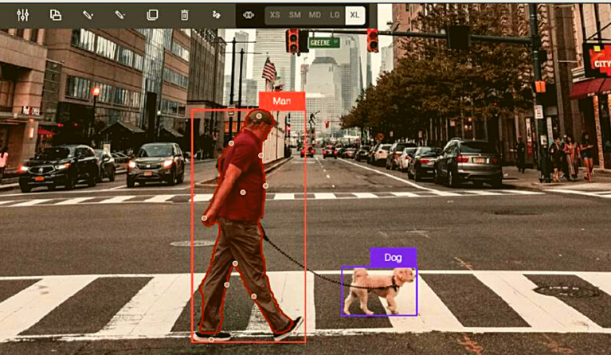

**2. Natural Language Processing (NLP):**

- NLP is a branch of machine learning that focuses on the interaction between computers and humans through natural language. A popular application of NLP is

language translation services like Google Translate. Here, machine learning models analyze text input in one language and accurately translate it into another language, preserving the original context and meaning.

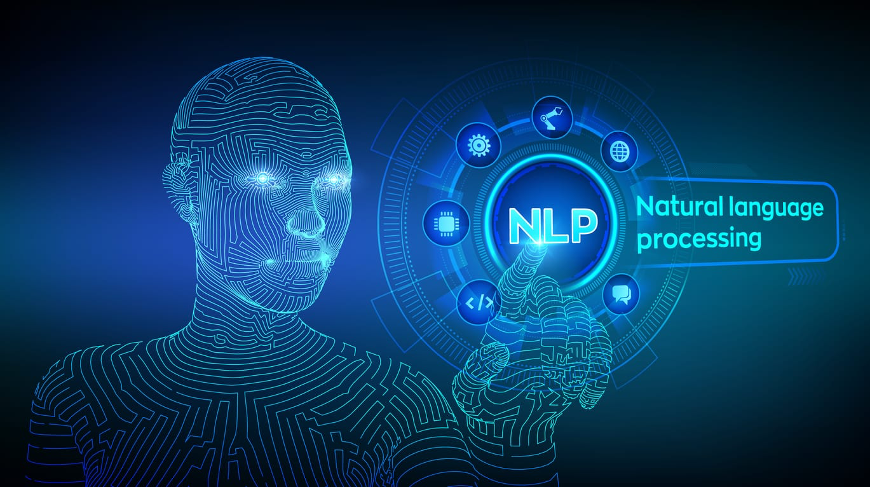

**3. Recommendation Systems:**

- Online platforms like Netflix, Amazon, and YouTube use machine learning-based recommendation systems to suggest content or products to users. These systems analyze users' past behavior, preferences, and browsing history to predict what the user might be interested in next, enhancing the user experience by providing personalized recommendations.

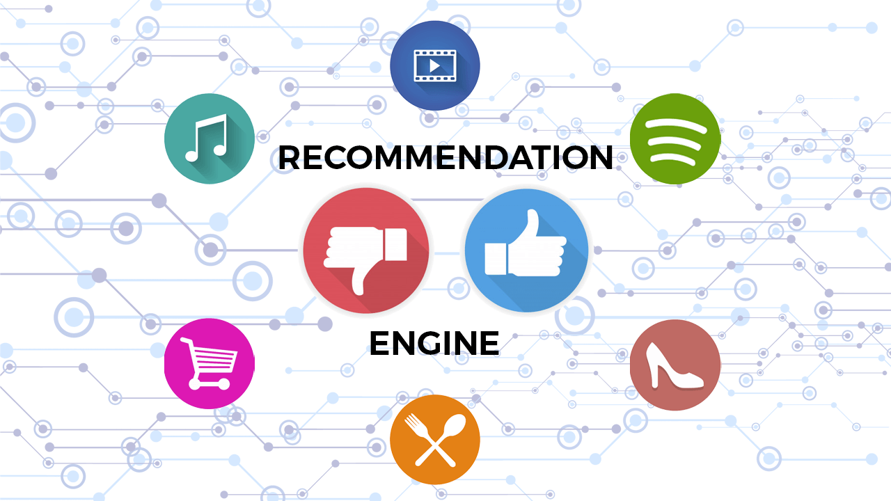

**4. Autonomous Vehicles:**

- Self-driving cars are a cutting-edge application of machine learning. These vehicles use a combination of senso

rs, cameras, and machine learning algorithms to interpret their surroundings, make decisions, and navigate roads safely. Machine learning helps the vehicle to recognize objects like pedestrians, other vehicles, and road signs, and to make split-second decisions to avoid accidents.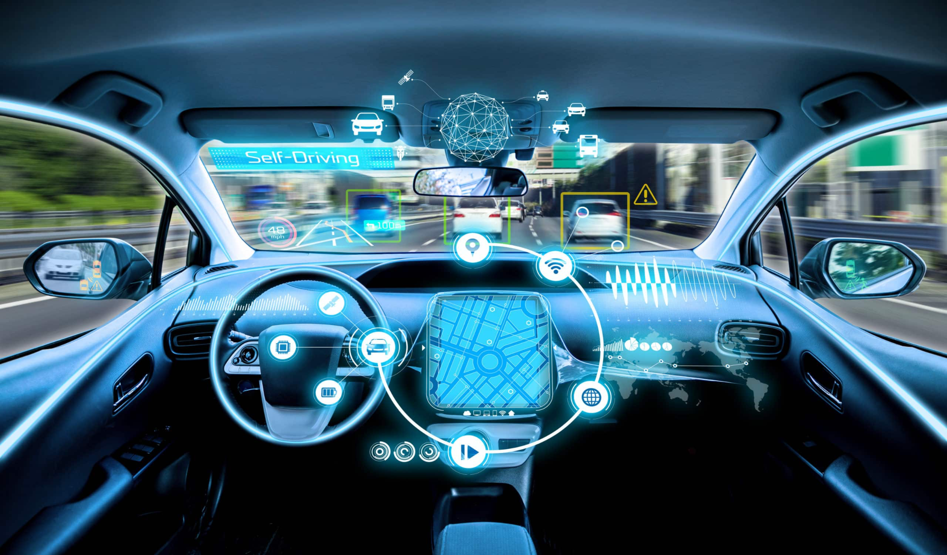

**5. Healthcare Diagnostics:**

- In healthcare, machine learning is used to improve diagnostic accuracy. For instance, algorithms can analyze medical images (such as X-rays or MRIs) to detect abnormalities like tumors or fractures. Machine learning models are trained on large datasets of medical images to learn patterns that signify specific health conditions, assisting doctors in making more accurate diagnoses.

